NANYANG TECHNOLOGICAL UNIVERSITY
SCHOOL OF PHYSICAL AND MATHEMATICAL SCIENCES


PS0002-INTRO TO DATA SCI&ART INTELL
Group Project
Feature Exploration & Multivariate Analysis on Wine’s Quality

Name | Matriculation Number
Song Yuli | U2040196B
Liu Yufei | U2040096E
Chen Zeyi | U2040386J

Table of Content

1 Introduction 2
2 Data Description 2
2.1 Data Overview 2
2.2 Visualization & Inferences 2
2.2.1 Histogram of quality. 2
2.2.2 Correlation Detection: Matrix Scatter Plot 2
2.2.3 Between-group Comparisons: Boxplots 2
3 Methods & Model Selection 3
3.1 Data Split 3
3.2 Regression Models 3
3.2.1 Predictions of density 3
3.2.1.1 KNN Regression 3
3.2.1.2 Linear Regression 3
3.2.2 Predictions of alcohol 3
3.2.2.1 KNN Regression 3
3.2.2.2 Linear Regression 3
3.3 Classification Models 3
3.3.1 Logistic Regression 3
3.3.2 KNN Classification 3
3.3.3 Support Vector Machine 3
4 Conclusion & Discussion 3
4.1 Summary of Results 3
4.2 Discussion & Potential Improvements 3
5 Acknowledgements 3
6 References 3

Introduction
In this project, we chose the “winequality-white” dataset obtained from the UCI Machine Learning Repository (2009) as our research subject. This dataset contains chemical features and compositions of the Portuguese "Vinho Verde" white wine (Cortez et al., 2009), and could provide some insights into how the chemical compositions work and how much does it affect the flavor of the wine.

Particularly, our main objective was to:
- Predict several necessary indexes including Alcohol and Density with other chemical and sensory variants known and available.
- Classify a white wine’s quality with the aid of both provided and estimated variables.

Data Description

Data Overview
Without missing values, the dataset contains 4898 observations and 12 variables. All of them are relevant to our research purposes due to their physicochemical characteristics. The variables consisted in the data are:

- fixed acidity (tartaric acid — g / dm³)
- volatile acidity (acetic acid — g / dm³)
- citric acid (g / dm³)
- residual sugar (g / dm³)
- chlorides (sodium chloride — g / dm³)
- free sulfur dioxide (mg / dm³)
- total sulfur dioxide (mg / dm³)
- density (g / cm³)
- pH
- sulphates (potassium sulphate — g / dm3)
- alcohol (% by volume)
- quality (score between 0 and 10)

The types of the variables are all “numeric”, except for fixed acidity, whose type is “character”. It is also remarkable that variable quality has scores reflecting different levels thus should be regarded as categorical. For the convenience of further investigation, we manually converted the types of fixed acidity and quality into “numeric” and “factor” respectively.

Visualization & Inferences

Histogram of quality.
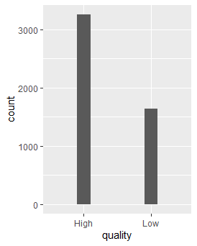
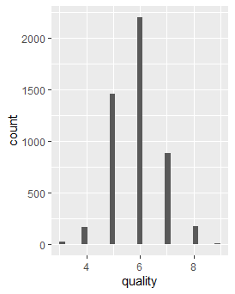
Figure 1 Histogram of pre-classified and re-classified quality distribution
From the histogram (left), we inferred that the initial sample data have quality with an imbalanced distribution since the observations for quality levels 5 and 6 have relatively larger frequencies than the rest. A classification result neglecting this feature could be highly biased due to a centralized training dataset. Hence, instead of proceeding with the initial quality levels, we generalized them into two categories, “Low” and “High” (represented by “0” and “1” in code), where “Low” included levels less or equal to 5 and “High” included others. We denoted this new binary variable by “y”. The histogram (right) shows that the new groups are more comparable to each other.

Correlation Detection: Matrix Scatter Plot
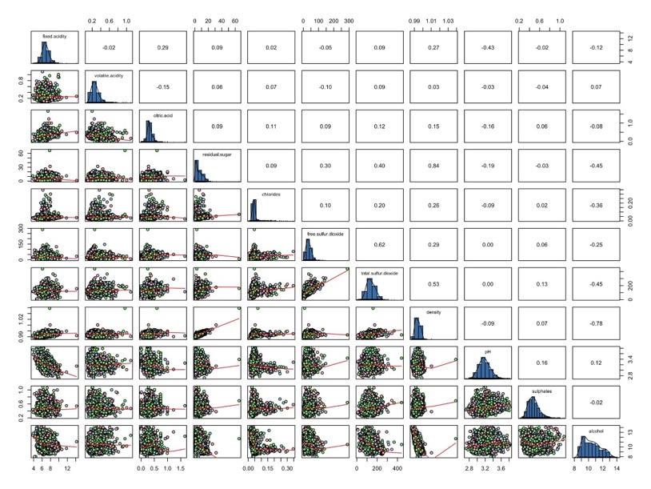
Figure 2 Matrix Scatter Plot
The matrix scatter plot was used for detecting the possible relationships between different indexes. For example, the plot displayed a highly negative correlation between density and alcohol ($-0.78$). In addition, density appears to be highly correlated to residual sugar (0.84). Such observations were the intuitive evidence and motivations for further regression analysis conducted in later sections.

Between-group Comparisons: Boxplots

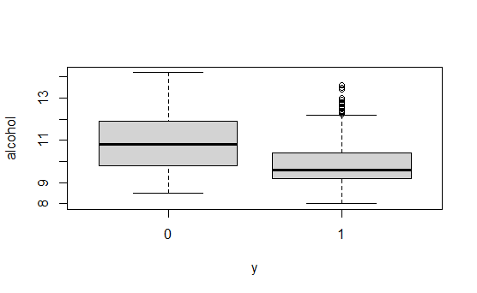
Figure 3 Boxplots for alcohol in the two groups
As defined, y is the new variable indicating quality. We conducted between-group comparisons to all numerical variables using boxplots (See Appendix). Most variables seemed not to vary obviously except for alcohol (as in Figure 3), on which we witnessed a significant difference between the two groups. To further convince, two-sample t test was conducted to reject the null hypothesis of equal group means. Therefore, we concluded that alcohol varies across the quality thus alcohol must be obtained before starting classification on quality.

Methods & Model Selection

Data Split
Using the 80/20 splitting rule, we randomly sampled 80% of the sample data for our model training while employing the remaining data as the test set. By comparing the predicted responses with the real test data, we constantly evaluate and modify our models.

Regression Models
For this part, we used the "lm" and "train" functions in R to perform linear and KNN regressions on density and alcohol separately. Suitable regression models were then derived and compared for the two variables, where our criterion included the RMSE performances as well as the residual behaviors.

Predictions of density
In our previous setting and discussion, density, alcohol and wine quality were assumed unknown, and density could be potentially predicted by the given variants due to high correlations.

Linear Regression
Linear regression is a fundamental tool to construct linear relationship supported by Least-Square estimators (LSEs). We tried linear regression to predict density by the remaining variants. First, we directly included all the other nine predictors in their first-order terms and performed the regression model. We obtained an R-square of 83.44%, an RMSE of 0.001311328. The residual plots are shown below, in which the random scatters formed a band approximately symmetric to the zero line and generally fell on the qq-normal line.
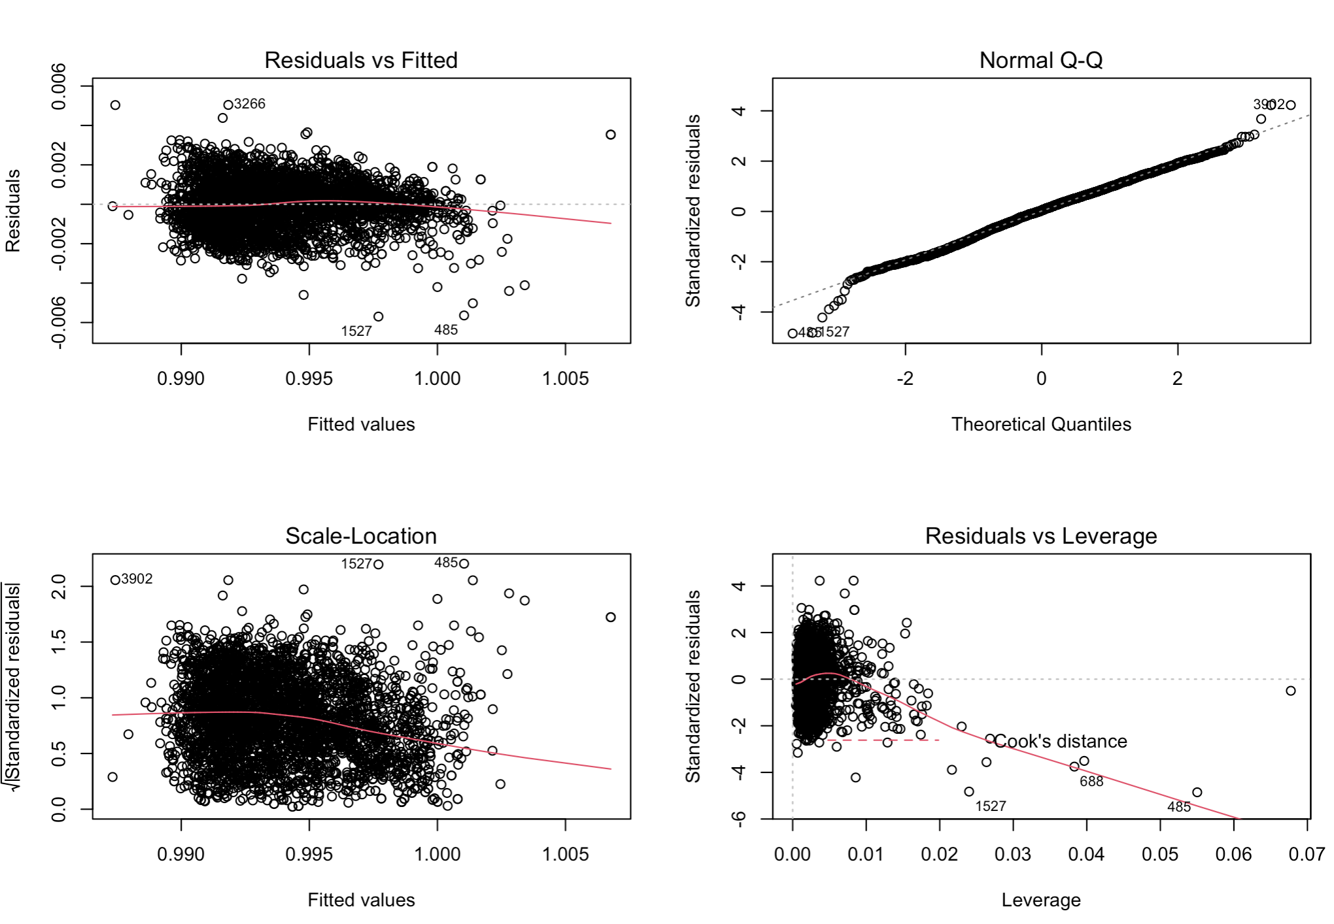
Figure 4 Residual Plot: LR - density
We then derived an adjusted model by eliminating some outliers and forming second-order terms using predicting variants which are highly related to density (identified using “corrplot” R package). The resultant model output an R-square of 80.87% as well as an RMSE of 0.00127333. Below are the corresponding residual plots. Whereas the Q-Q plot was ideal, there was an abnormal quadratic trend in the “Residuals vs Fitted” plot.
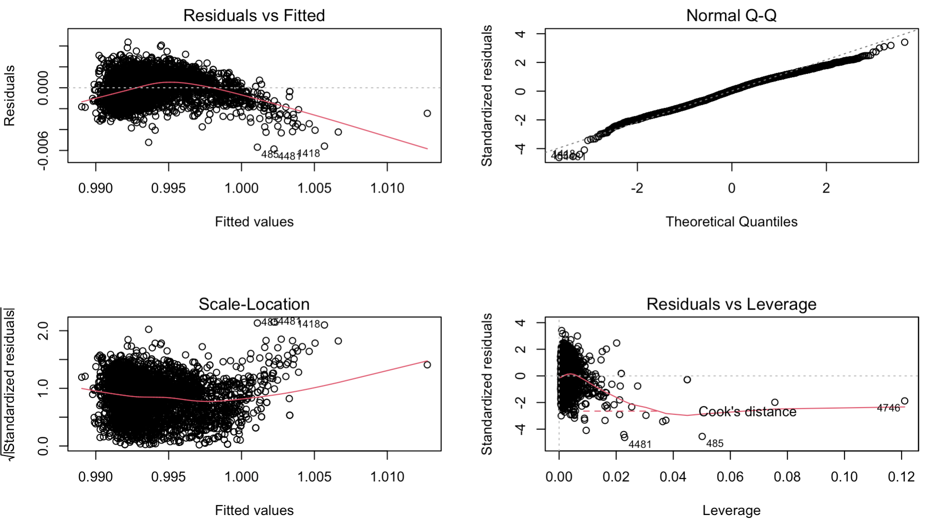
Figure 5 Residual Plot: adjusted LR - density
By comparing the two models, we concluded that while the RMSE of the adjusted model is 3% lower than the original linear model, the residual plot of the original linear model looked much better than the adjusted one in shape and distribution. To avoid violating the assumption of “independent error terms” made in linear regression, we preferred the pre-adjusted one.

KNN Regression
KNN regression considers the average of the responses among the K nearest neighbor as the predicted response of a new observation. In this context, the nine predictors were directly used as predictors in the KNN regression model. The optimal K was tuned to be 7 and an RMSE of 0.001572351 was realized, larger than that of the linear regression model. We ended up determining the linear regression as a more appropriate method for the task.

Predictions of alcohol
Now that the density has been estimated and a high correlation between density and alcohol was observed in the Matrix Scatter Plot, it was natural to involve density as a regressor for alcohol.

Linear Regression
The linear regression model considering each first-order predictor gave an R-square of 90.48% and an RMSE of 0.6576248. As shown in Figure 6, a slight quadratic trend can be observed in the residual plot and there were points departing from the normal line in the right of Q-Q plot, suggesting residual behaviors against model assumptions.
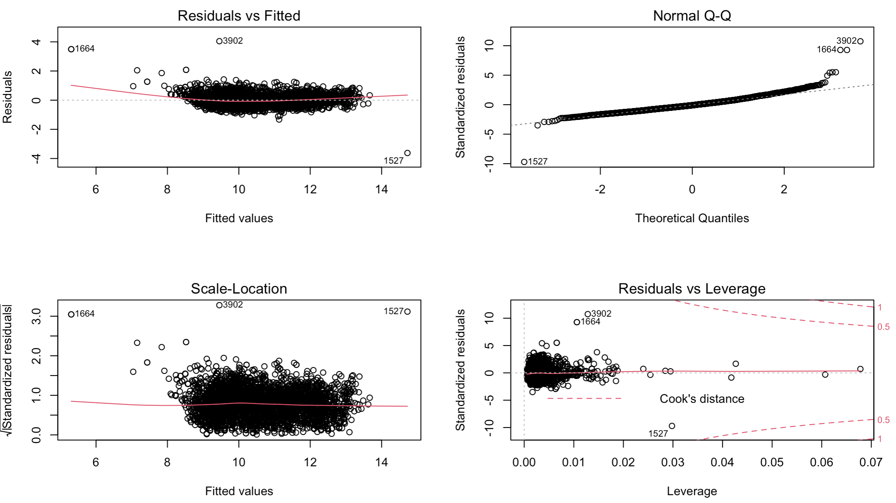
Figure 6 Residual Plot: LR - alcohol
Like the linear regression procedure on density, we proposed an adjusted model discarding obvious outliers and interacting with some highly related second-order terms. This time the adjusted model seemed better as an R-square of 87.01% as well as an RMSE of 0.4438751 were given, both of which outperformed the raw model. Note that the new RMSE was 32.5% down from the previous one. The residual plot was satisfactory without any abnormal pattern around the base line, and the adjusted model’s residuals’ normality is also stronger than the original model according to the Q-Q plot. Both plots are shown as below (Figure 7).
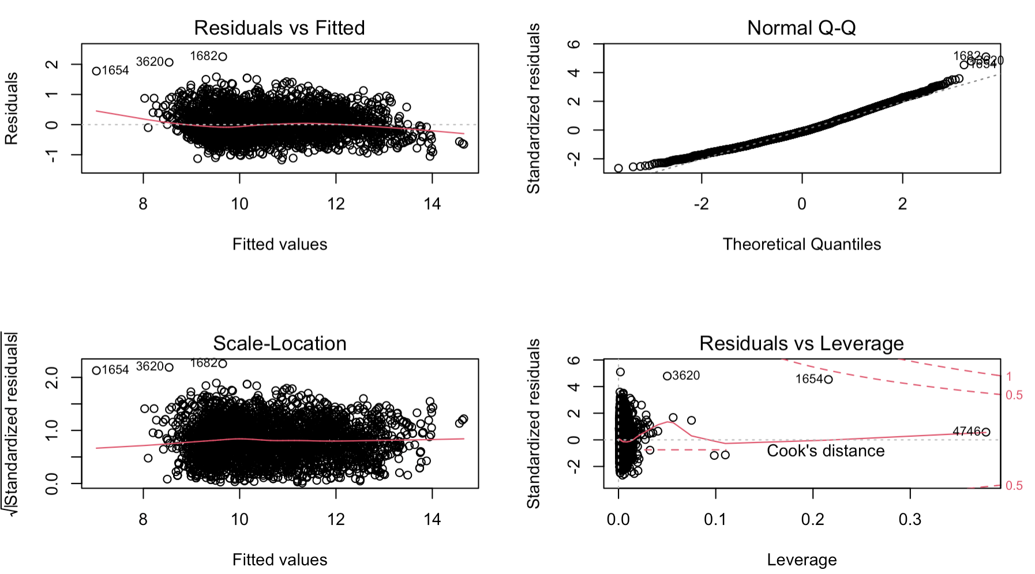
Figure 7 Residual Plot: adjusted LR - alcohol

KNN Regression
The ten predictors were directly used as predictors in the KNN regression model. The optimal K was tuned to be 5 and an RMSE of 0.5628379 was realized, larger than that of the linear regression model. Therefore, we ended up accepting the adjusted linear model as the best model for the task.

Classification Models
In this section, we gathered all available variables to build up models for classifying quality levels (high or low). The model selection was referred to the average consistency between expected and real categories of our test data. Possible candidates included logistic regression, KNN and SVM.

Logistic Regression
Logistic Regression extends linear regression to probabilities and gives binary outcomes. In this section, we constructed a logistic regression model via the function glm() to classify the quality. Based on the confusion matrix, we got the accuracy of the classification to be 73.2%.
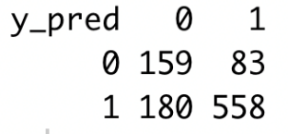
Table 1 Confusion Matrix: logistic regression

KNN Classification
KNN algorithm calculates the k smallest distance between the input vector and other points in the training data. The most represented class by these K neighbors is considered as the class of input value.

In this subsection, we normalized our data and built the simple model using knn() function from R packages “class”, where we firstly set K = 2. The accuracy of this situation was 69.6%. To find the optimal K value constructing best classifier, we made K iterate from 1 to 30. In the end, we get the summary accuracy output and an accuracy plot.
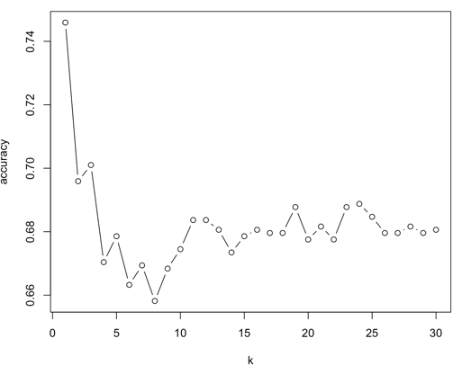
Figure 8 KNN Tuning
A small value of k makes the prediction result extremely sensitive to the neighboring points, which can be easily misled by noises. Hence, rather than choosing K = 1, we tended to select the next optimal parameter K = 3, resulting in the best accuracy of 70.1%.

Support Vector Machine (SVM)
Support Vector Machine (SVM) generates optimal boundary hyperplanes to maximize the margins between the classifier and the support vectors. Particularly, we applied SVM to our data thus constructing high-dimensional boundaries between the two categories of quality. We implemented the SVM model via the function svm() in the “e1071” packages of R.
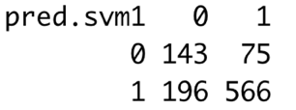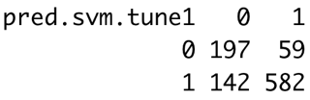
Table 2 Confusion Matrices: linear SVM (left) & radical SVM (right)
Considering in all numerical components, we first tried a linear decision boundary to see whether it sufficed to give ideal classifications with respect to our test data. The accuracy for the linear SVM was 72.3%, close to that of logistic regression. To further improve, radical kernel with parameters tuned was proposed to conduct appropriate transformations. The rate of accuracy, as expected, grew to 79.5%, and the contingency table (Table 2) had fewer errors. This model prevailed all previous ones on the grouping performance.

Conclusion & Discussions

Summary of Results
In a nutshell, using available variables in our setting, we successfully generated models with satisfactory accuracy to predict density and alcohol, which proved to be key in classifying the final quality level. Linear regression containing all first- order predicting variables was selected to estimate density with RMSE = 0.0013, while the optimal model for regressing on alcohol contains several second-order terms and gave RMSE = 0.4439. The prioritized classification model to identify qualities was the SVM model with 79.5% accuracy.

Discussion & Potential Improvements
In general, the performances given by the optimal models were acceptable, in both regression and classification tasking. However, to further improve the modelling, one may consider the following aspects:
- The overfitting problem. Although the linear regression model gave impressive prediction accuracy, the model might be overfitted as all variables were included. One may check whether there will be equivalently good performance with less regressors involved.
- Ordinal categorical variables. The quality in this data could be regarded as ordinal (according to its definition and distribution). Hence, models like ordinal regression can be introduced to address such phenomenon.

Acknowledgement
The project was supported by the whole team and each member had equal contribution.

References
The UCI Machine Learning Repository. (2009). Wine Quality Data Set. Retrieved from https://archive.ics.uci.edu/ml/datasets/wine+quality

Cortez P, Cerdeira A, Almeida F, Matos T and Reis J. (2009). Modeling wine preferences by data mining from physicochemical properties. Decision Support Systems, Elsevier. 47(4):547-553.
Appendix
- Relevant Figures

- Boxplots for Between-Group Comparisons
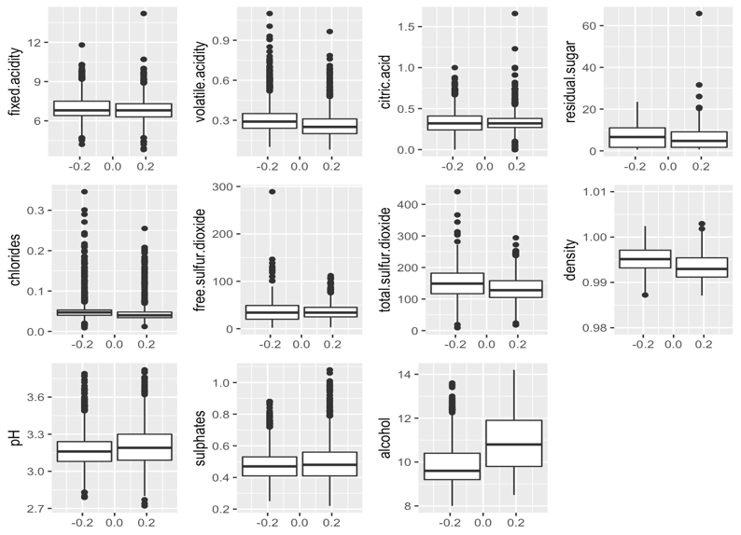

- Linear Regression Prediction Performances
- Original LR: Density
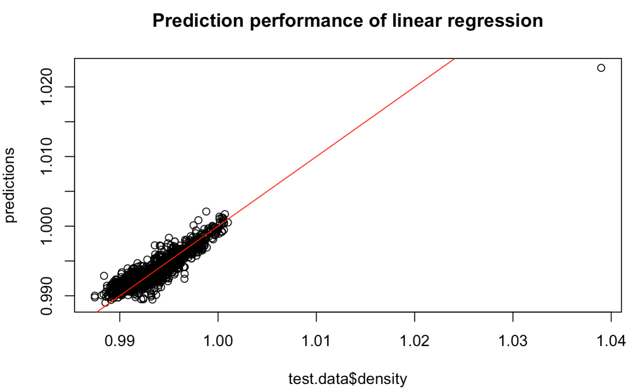
- Adjusted LR: Density
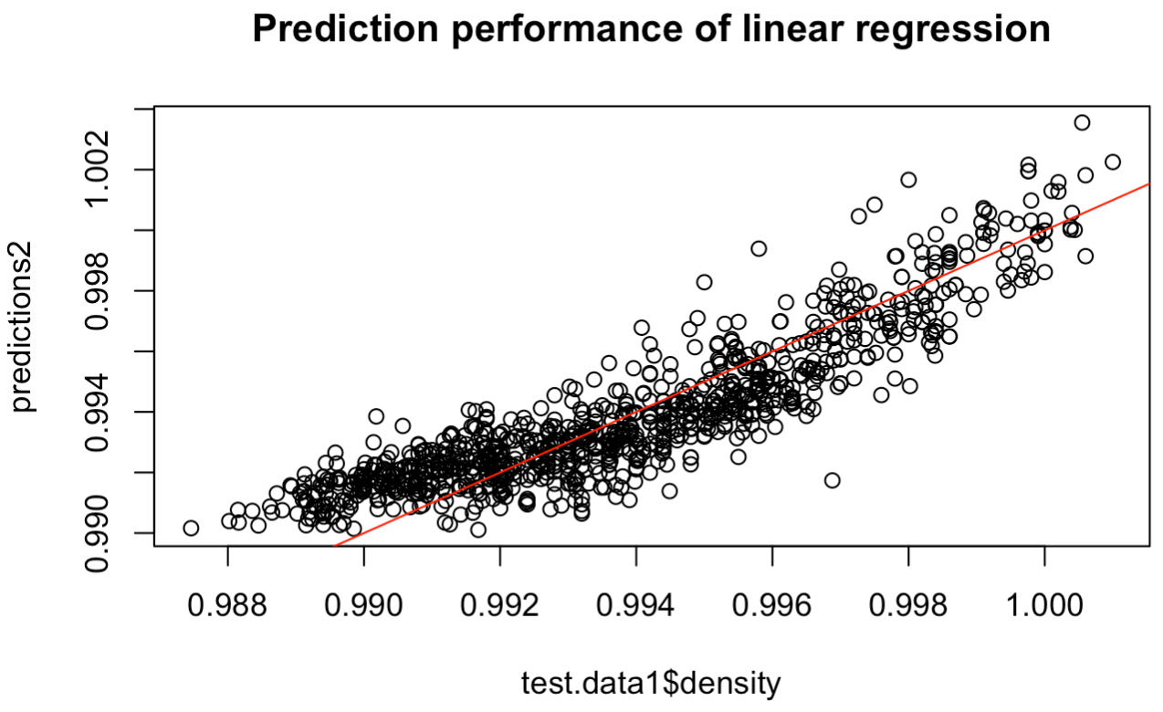
- Original LR: Alcohol
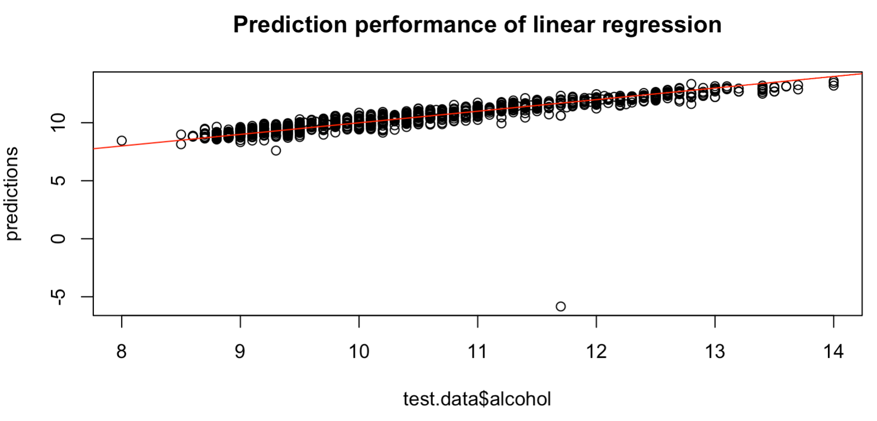
- Adjusted LR: Alcohol
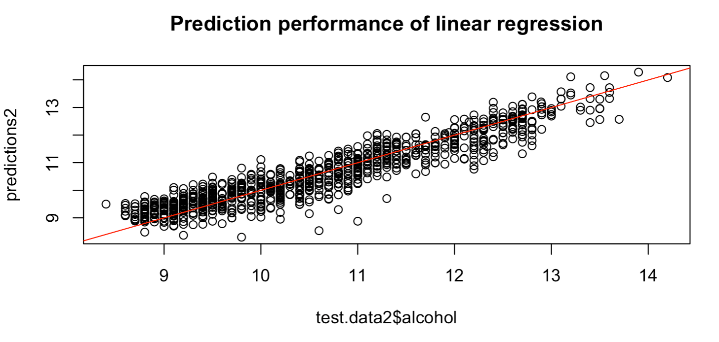
- KNN Regression Tuning
- Density
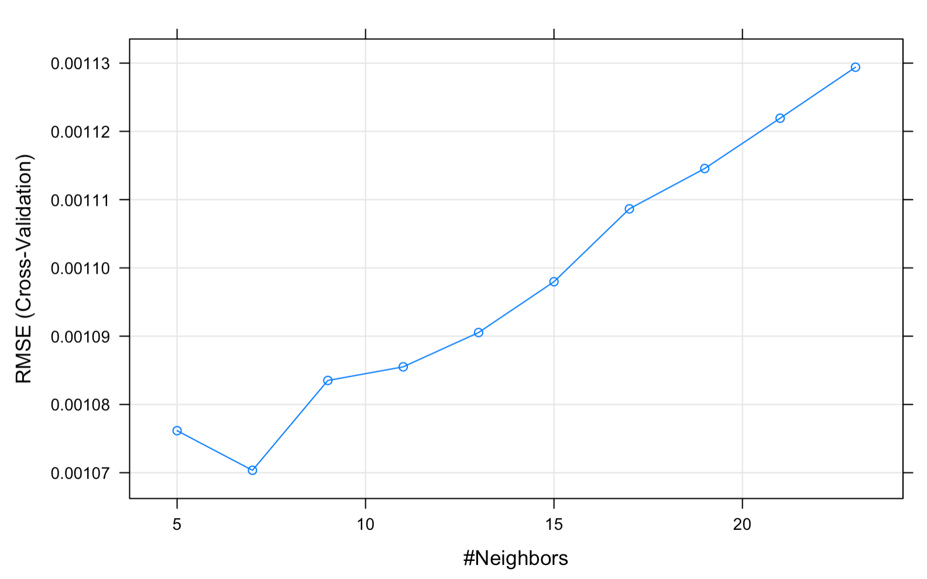
- Alcohol
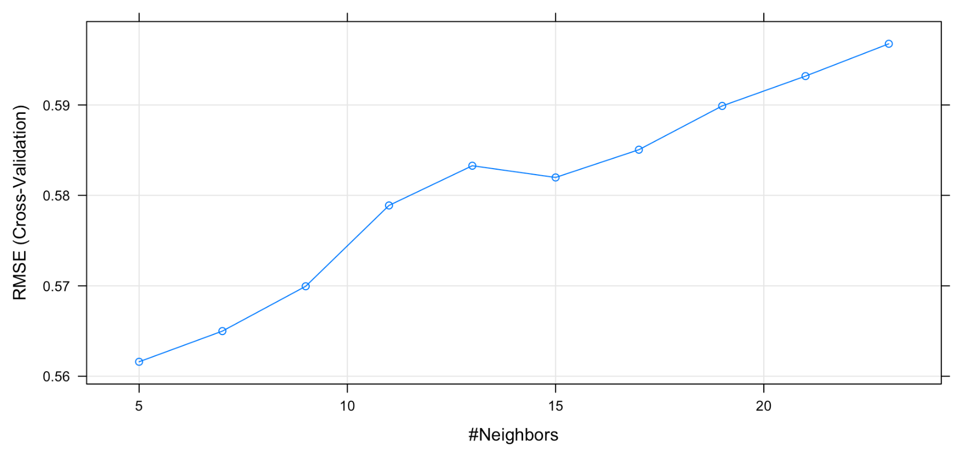

- KNN Regression Prediction Performances
- Density
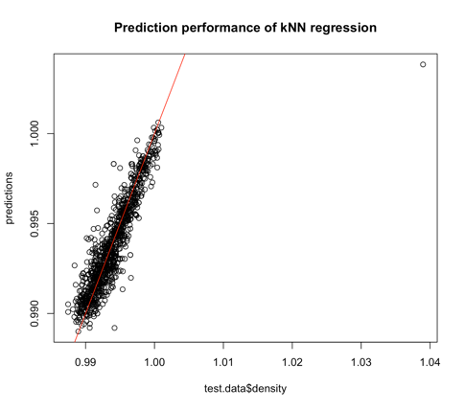
- Alcohol
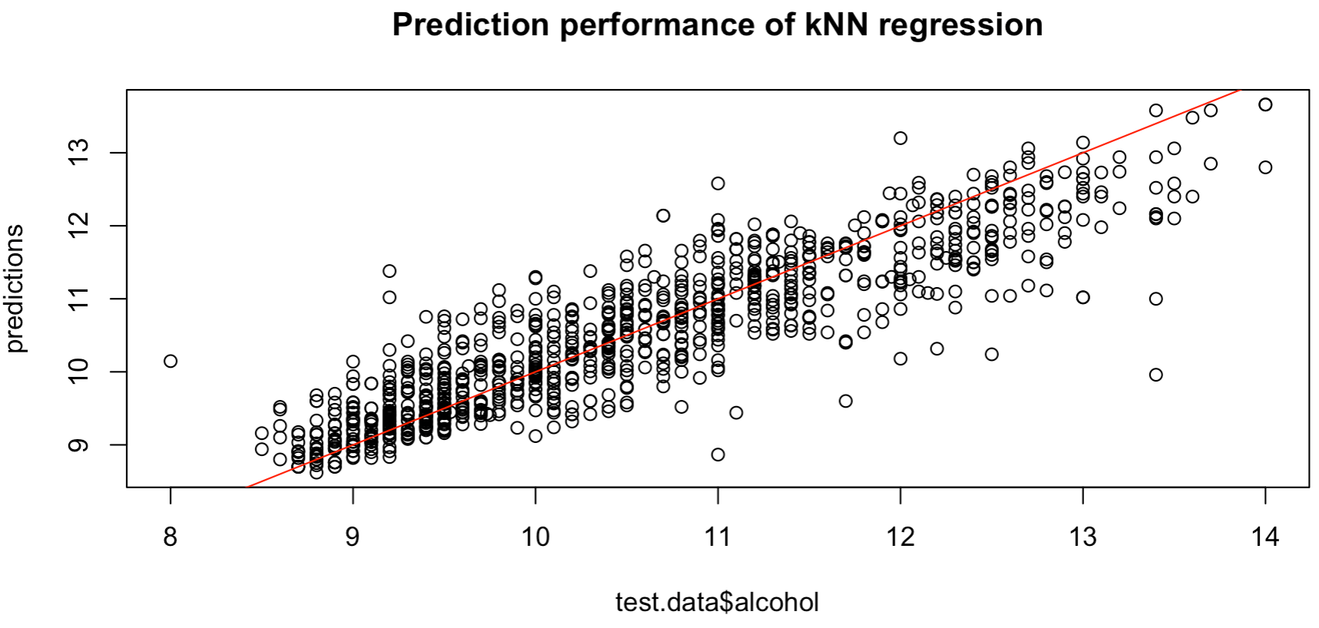

- Code Availability
final code.R

- Code Availability

